Biology 102
Laboratory 4: Porifera & Cnidaria

Reading:
Inquiry into life: Laboratory Manual – p. 377 – 387

A: Taxonomy:

Phylum Porifera (Sponges: p. 379 - 383)
Class Calcarea – Calcareous sponges
Grantia

Class Hexactinellidae – Glass sponges
Class Demospongiae – Horny sponges

Phylum Cnidaria (p. 383 – 387)
Class Hydrozoa (Hydriods and Siphonophores)
Hydra
Obelia

Class Scyphoza (True Jellyfish)
Class Anthozoa (Sea Anemones and Corals)

B: Introduction
In today’s lab, we will begin our journey into the animal kingdom. We will be investigating Sponges and Cnidarias, which are are invertebrates and lack a true body cavity.

Porifera
Porifera is latin for “pore bearing”. Sponges are multicelluar and have a cellular level of organization. Their cells do not form well organized and distinct layers, which means they lack tissues, organs, and organ systems. Adult sponges are sessile, meaning they are permanently attached to their environment and not capable of moving. Because they are sessile, sponges have several adaptations for feeding.
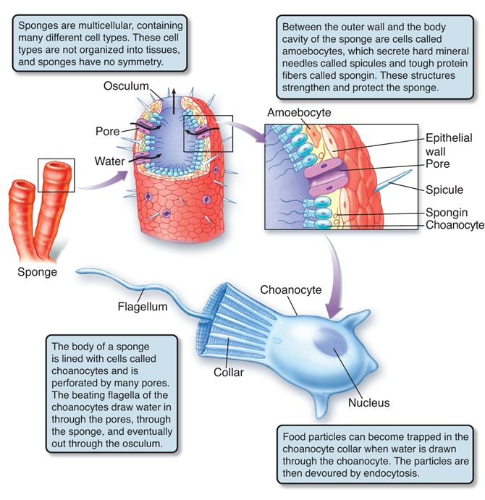
Sponges are characterized as filter feeders, consuming bacteria size food particles that are floating in the water column. Examine the pore bearing structure located in the figure to understand how water flows through a sponge. The wall of a sponge has three types of cells: epidermal cells, amoebocytes, and choanocytes. To feed, this system of cells is able to move nutrient and oxygen rich water through the pores. Water enters through the pores and exits through the osculum. Choanocytes are flagellated cells that line the interior of the sponge, creating water currents with the flagellum, and filter food particles from the water column.
Things to know:
- Function of epidermal cells
- Function of choanocytes
- Function of amoebocytes
- How does water flow though a sponge?
- What are spicules?
- How does species in Porifera feed?
Cnidaria
Species in the phylum Cnidaria are characterized by having tissue level of organization. Their body plant is diploblastic, meaning they are composed of two germ layers. The outer epidermal tissue is derived from embryonic ectoderm and the inner epidermal tissue layer is derived from embryonic endoderm. There is a gelatinous connective tissue layer, mesoglea, which is between the ectoderm and endoderm. The mouth is the only opening to the gastrovascular cavity (coelenteron). The mouth is usually surrounded by tentacles that contain nematocysts.
All species in Cnidaria have specialized stinging cell called nematocysts. Each nematocysts develops in interstitial cells and has a small trigger-like projection that is sensitive to chemical or mechanical simulation by food, prey, or enemies. Gland cells produce mucoid secretions and digestive enzymes. Gland cells are located in the epidermal and gastrodermal layer.
The Cnidarian life cycleis composed of a free swimming medusa (sexual) or an attached polyp (asexual). In lab, we will be examining Obelia to better understand the Cnidarian life cycle.

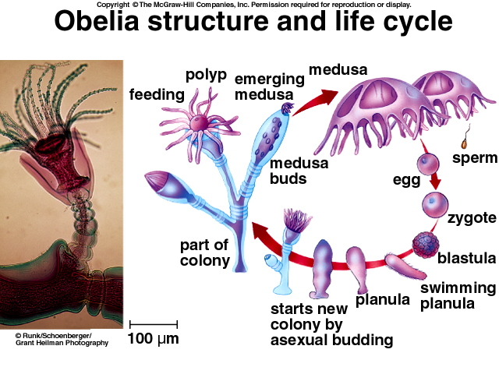
Things to know:
- What is the polyp stage?
- What is the medusa stage?
- What are the specialized cells?
- Diploblastic
  - Endoderm
  - Mesoglea
  - Ectoderm

C. Procedure:
- Prepared Slides: Grantia c.s., Granita spicules, Hydra c.s., Obelia
- Preserved specimens:
  - Sponges (Glass, Bath, and Calcarerous sponges)
  - Cnidaria (Sea anemone, jellyfish, and corals)
- Live organisms: Hydra (predator) and Dafnia (prey)

- Grantia – Obtain a prepared cross section (c.s) slide of the sponge, Grantia. Before observing with a microscope, hold the slide up to the light in the laboratory and notice how the cross section looks circular to the naked eye. This shows the radial symmetry of the sponge.
Observe the slide under low power, and you should notice that the majority of the sponge is a large, empty, cavity. This is called the spongocoel. Now focus on the body wall, you should see two canals. The canal that is open to the outside via the ostium (pores) is the incurrent canal. The other canal, which opens to the spongocoel, is called the radial canal. Before you draw the Grantia c.s., examine a preserve sponge and visualize cutting the sponge and making a cross section slide.
Draw Grantia (c.s.) and identify spongocoel, incurrent canal, and radial canal.
- Grantia spicules – Examine the (w.m.) slide of Grantia spicules. You should notice that spicules are rigid, geometric, and transparent. The spicules that you observe have three rays and are calcium carbonate. Spicules are embedded in the walls of sponges to provide support.
Draw and identify Grantia spicules .
- Preserved sponges:
  - Calcarea sponges
  - Hexactinellidae sponges
  - Demospongiae sponges
- Hydra – Obtain a live Hydra and prepared cross section of Hydra. This hydrozoan characterizes the polyp form for the phylum Cnidaria. Using low power (40x), label the mouth, basal disk, epidermis, and tentacle. For the cross section, identify and label body wall, epidermis, gastrodermis, gastrovascular cavity (coelenterons), and mesoglea. See page 384 for a labeled diagram.
Describe the movement of the live Hydra.
- Predator prey: Live Hydra and Live Daphnia: Obtain a watch glass and add live Hydra and Daphnia. Using a dissecting microscope, observe and describe the interactions between Daphnia and Hydra.
- Obelia colony – Obtain a whole mount (w.m.) of a colonial hydroid, Obelia. We are using Obelia as example of the typical hydrozoan life cycle. See page 383 in your lab manual for the life cycle of Obelia.
  - Polyp generation: The feeding polyp is called gastrozooid, which contains the hydranth and tentacles around the mouth. The feeding polyp uses tentacles to capture prey and sting it using nematocyst cells.
The gonozooid is the reproductive structure and produce medusae via asexual budding. Draw and identify the polyp and medusa stage for Obelia.
  - Medusa generation: Hydrozoan medusa are free swimming, sexually reproducing individuals. When you think of jellyfish, you are probably thinking of the medusa generation. The saucer like body is called the bell. The upper, convex, side is called the exumbrella and the lower, concave, surface is called the subumbrella. The mouth is in the center of the subumbrella and is surrounded by four oral arms.
  - Follow the lab hand out for what to draw and label.
- Preserved Cnidarians:
  - Sea Anemone
  - Jellyfish
  - Coral

